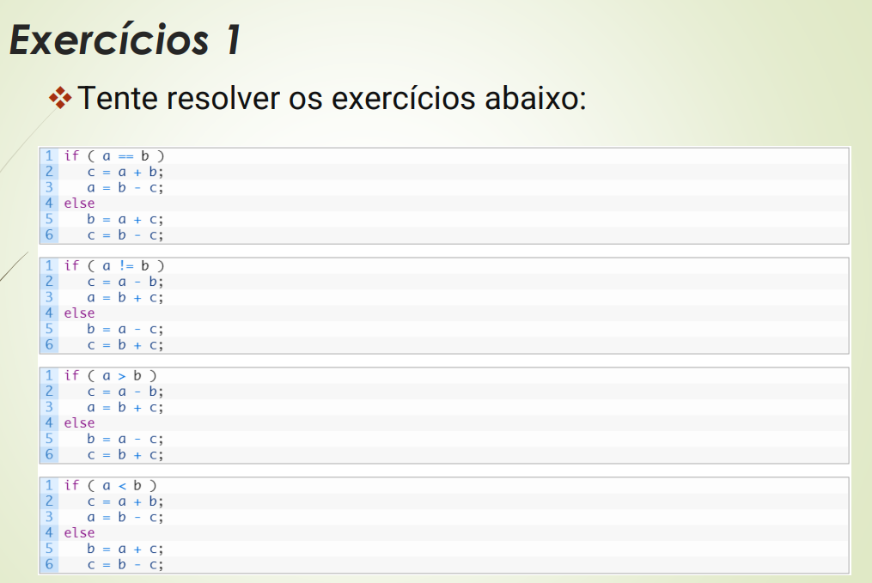
Exercício 1a:

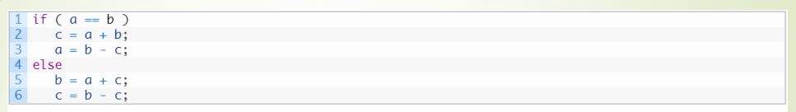
- Linguagem de máquina
- Linguagem de Montagem
- Representação de linguagem de máquina
- Código de máquina
1: BNE $s0, $s1, ELSE
ADD $s2, $s0, $s1
SUB $s0, $s1, $s2
J EXIT
ELSE: ADD $s1, $s0, $s2
ELSE: SUB $s2, $s1, $s2
EXIT

2: BNE $16, $17, ELSE
ADD $18, $16, $17
SUB $16, $17, $18
J EXIT
ELSE: ADD $17, $16, $18
ELSE: SUB $18, $17, $18
EXIT

3:
Endereço | OpCode | Rs | Rt | Rd | Shamt | Funct
10000 | 4 | 16 | 17 | 10020
10004 | 0 | 16 | 17 | 18 | 0 | 32
10008 | 0 | 17 | 18 | 16 | 0 | 34
10012 | 2 | 10028
10020 | 0 | 16 | 18 | 17 | 0 | 32
10024 | 0 | 17 | 18 | 18 | 0 | 34
10028 | EXIT

4:
000100.10000.10001.00100.11100.100100
000000.10000.10001.10010.00000.100000
000000.10001.10010.10000.00000.100010
000010.00000.00000.00100.11100.101100
000000.10000.10010.10001.00000.100000
000000.10001.10010.10010.00000.100010

Exercício 1b:

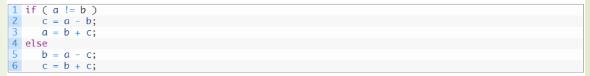
1: BEQ $s0, $s1, ELSE
SUB $s2, $s0, $s1
ADD $s0, $s1, $s2
J EXIT
ELSE: SUB $s1, $s0, $s2
ELSE: ADD $s2, $s1, $s2
EXIT

2: BEQ $16, $17, ELSE
SUB $18, $16, $17
ADD $16, $17, $18
J EXIT
ELSE: SUB $17, $16, $18
ELSE: ADD $18, $17, $18
EXIT

Endereço | OpCode | Rs | Rt | Rd | Shamt | Funct
10000 | 4 | 16 | 17 | 10020
10004 | 0 | 16 | 17 | 18 | 0 | 32
10008 | 0 | 17 | 18 | 16 | 0 | 34
10012 | 2 | 10028
10020 | 0 | 16 | 18 | 17 | 0 | 32
10024 | 0 | 17 | 18 | 18 | 0 | 34
10028 | EXIT

4:
000100.10000.10001.00100.11100.100100
000000.10000.10001.10010.00000.100000
000000.10001.10010.10000.00000.100010
000010.00000.00000.00100.11100.101100
000000.10000.10010.10001.00000.100000
000000.10001.10010.10010.00000.100010

Exercício 1c e Exercício 2a:
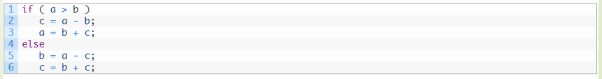
1: SLT $t0, $s1, $s0
BNE $t0, $zero, ELSE
SUB $s2, $s0, $s1
ADD $s0, $s1, $s2
J EXIT
ELSE: SUB $s1, $s0, $s2
ELSE: ADD $s2, $s1, $s2
EXIT

2: SLT $8, $17, $16
BNE $8, $zero, ELSE
SUB $18, $16, $17
ADD $16, $17, $18
J EXIT
ELSE: SUB $17, $16, $18
ELSE: ADD $18, $17, $18
EXIT
3:
Endereço | OpCode | Rs | Rt | Rd | Shamt | Funct
10000 | 0 | 17 | 16 | 8 | 0 | 42
10004 | 4 | 8 | zero | 10024
10008 | 0 | 16 | 17 | 18 | 0 | 32
10012 | 0 | 17 | 18 | 16 | 0 | 34
10020 | 2 | 10032
10024 | 0 | 16 | 18 | 17 | 0 | 32
10028 | 0 | 17 | 18 | 18 | 0 | 34
10032 | EXIT

4:
000000.10001.10000.01000.00000.101010
000100.01000.00000.00100.11100.101000
000000.10000.10001.10010.00000.100000
000000.10001.10010.10000.00000.100010
000010.00000.00000.00100.11100.101100
000000.10000.10010.10001.00000.100000
000000.10001.10010.10010.00000.100010

Exercício 1d e Exercício 2b:

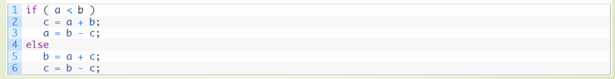
1: SLT $t0, $s0, $s1
BNE $t0, $zero, ELSE
ADD $s2, $s0, $s1
SUB $s0, $s1, $s2
J EXIT
ELSE: ADD $s1, $s0, $s2
ELSE: SUB $s2, $s1, $s2
EXIT

2: SLT $8, $17, $16
BNE $8, $zero, ELSE
ADD $18, $16, $17
SUB $16, $17, $18
J EXIT
ELSE: ADD $17, $16, $18
ELSE: SUB $18, $17, $18
EXIT
3:

Endereço | OpCode | Rs | Rt | Rd | Shamt | Funct
10000 | 0 | 16 | 17 | 8 | 0 | 42
10004 | 4 | 8 | zero | 10024
10008 | 0 | 16 | 17 | 18 | 0 | 32
10012 | 0 | 17 | 18 | 16 | 0 | 34
10020 | 2 | 10032
10024 | 0 | 16 | 18 | 17 | 0 | 32
10028 | 0 | 17 | 18 | 18 | 0 | 34
10032 | EXIT

4:
000000.10000.10001.01000.00000.101010
000100.01000.00000.00100.11100.101000
000000.10000.10001.10010.00000.100000
000000.10001.10010.10000.00000.100010
000010.00000.00000.00100.11100.101100
000000.10000.10010.10001.00000.100000
000000.10001.10010.10010.00000.100010

